Practical 10
Aim : Commands in impala

impala-shell
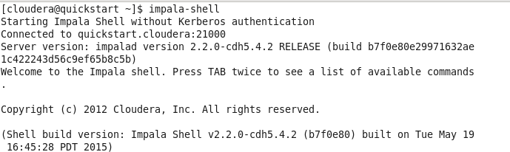

select version();
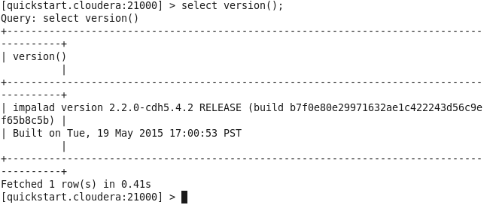

Show databases: This command will list existing databases in impala.

show databases;
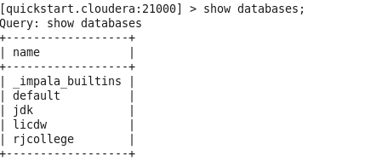

select current_database();

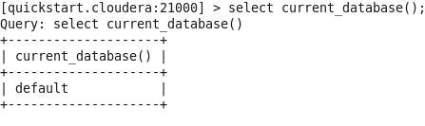
show tables;
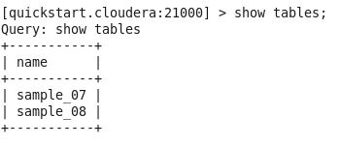
show tables in jdk;

show tables like 'sample*';
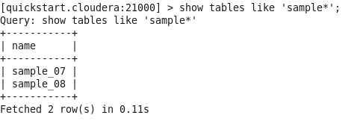
Create a database: This command is used to create a database.
Syntax: create database <database_name>
create database RJ;

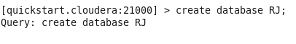
show databases;
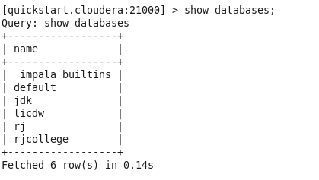
use RJ;
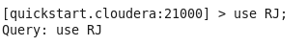

Create table: This command is used to create tables.
Syntax: create table <table_name>(field_name1 data_type, field_name2 data_type);
create table t1 (x int);
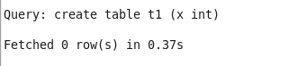

Show tables is used to view all the tables in current database

show tables;
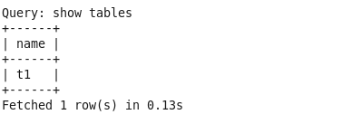

select current_database();
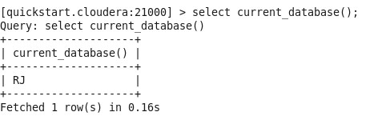

Insert: This command is used to insert records in either overwrite or append record in tables.
Syntax: Insert into <database_name>.<table_name> values(field_value1, field_value2)
insert into t1 values (1),(3),(2),(4);
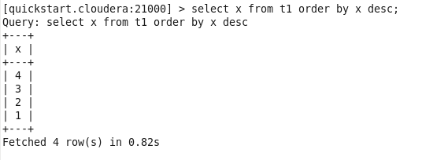

Order by : This is used to sort the data

select x from t1 order by x desc;
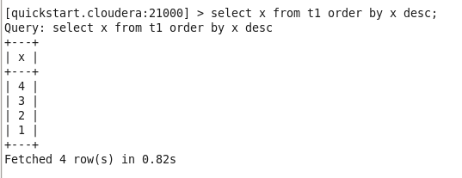

Aggregate functions:
select min(x), max(x), sum(x), avg(x) from t1;
